prioritized avian predation deterrent alternative actions
Ice Harbor Dam
October, 2013

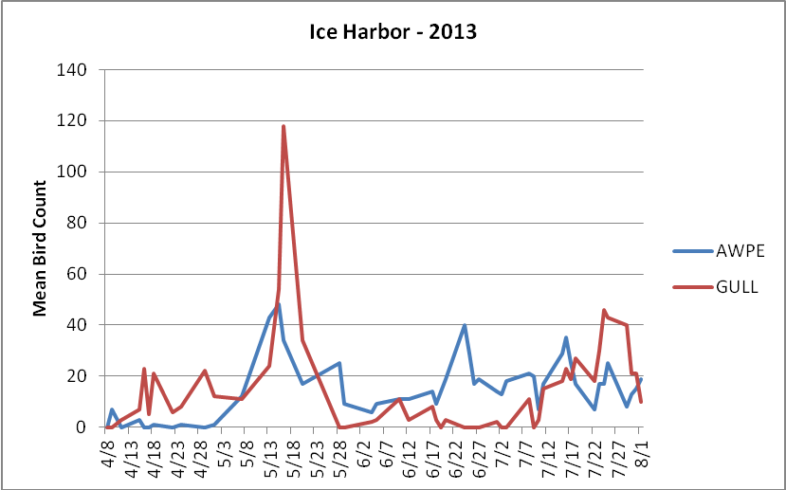

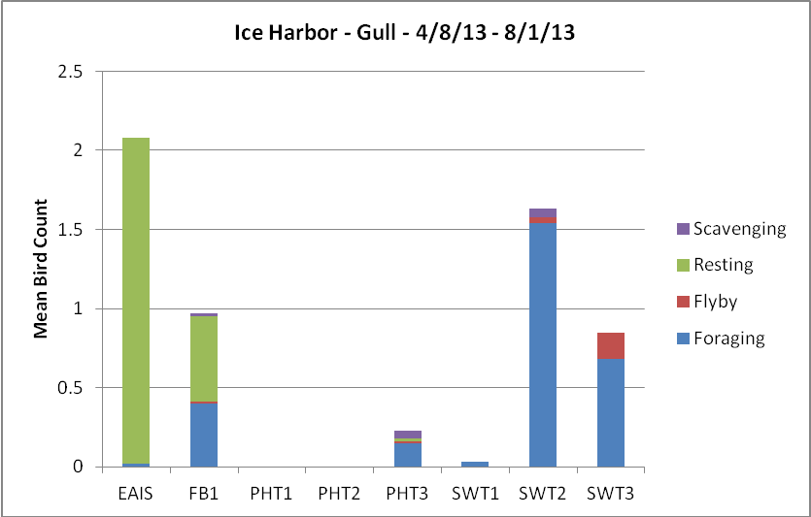

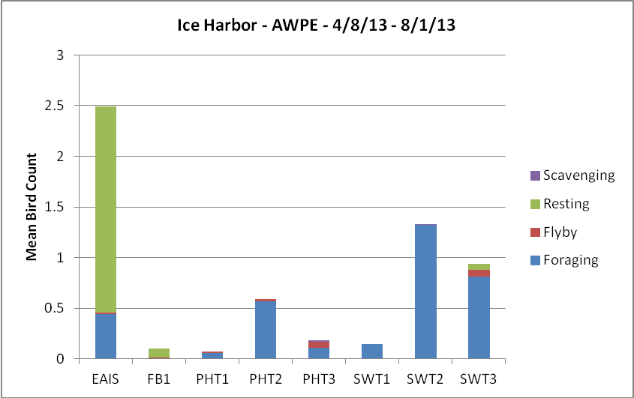

Planned for 2014:

1. Continue with current avian deterrent program, with limited lethal take of gulls added in.

Wish List:

2. Turn Ice Harbor Juvenile Fish Facility into a juvenile fish collection and holding facility, so fish can be transported out of Ice Harbor. This way, the fish would not be exposed to piscivorous birds on their journey in barges and trucks downstream to Bonneville Dam.

3. Install roosting deterrents on the boat barrier floats located in the forebay. Throughout the juvenile fish season, gulls and cormorants are observed resting/loafing on these floats. The floats are located at a distance from the dam and shoreline that prevents normal hazing efforts from the USDA agents.

